Appendix A: Supplementary Figures
This appendix presents figures generated during the research pipeline that supplement or contextualise the results in Chapters 4 and 5. Figures are grouped thematically. All results derive from the JST Macrohistory Database R6 (18 advanced economies, 1985–2020) and the FinBERT-processed BIS central bank speech corpus, unless stated otherwise. Figures already embedded in the main chapters (Figures 4.1–4.11 and 5.1a–5.1b) are excluded.

A.1 Dataset and Crisis Distribution
Figure A.1 shows the full temporal distribution of banking crisis onsets across the 18-country panel, distinguishing the Stage 1 extension window from the original evaluation period.
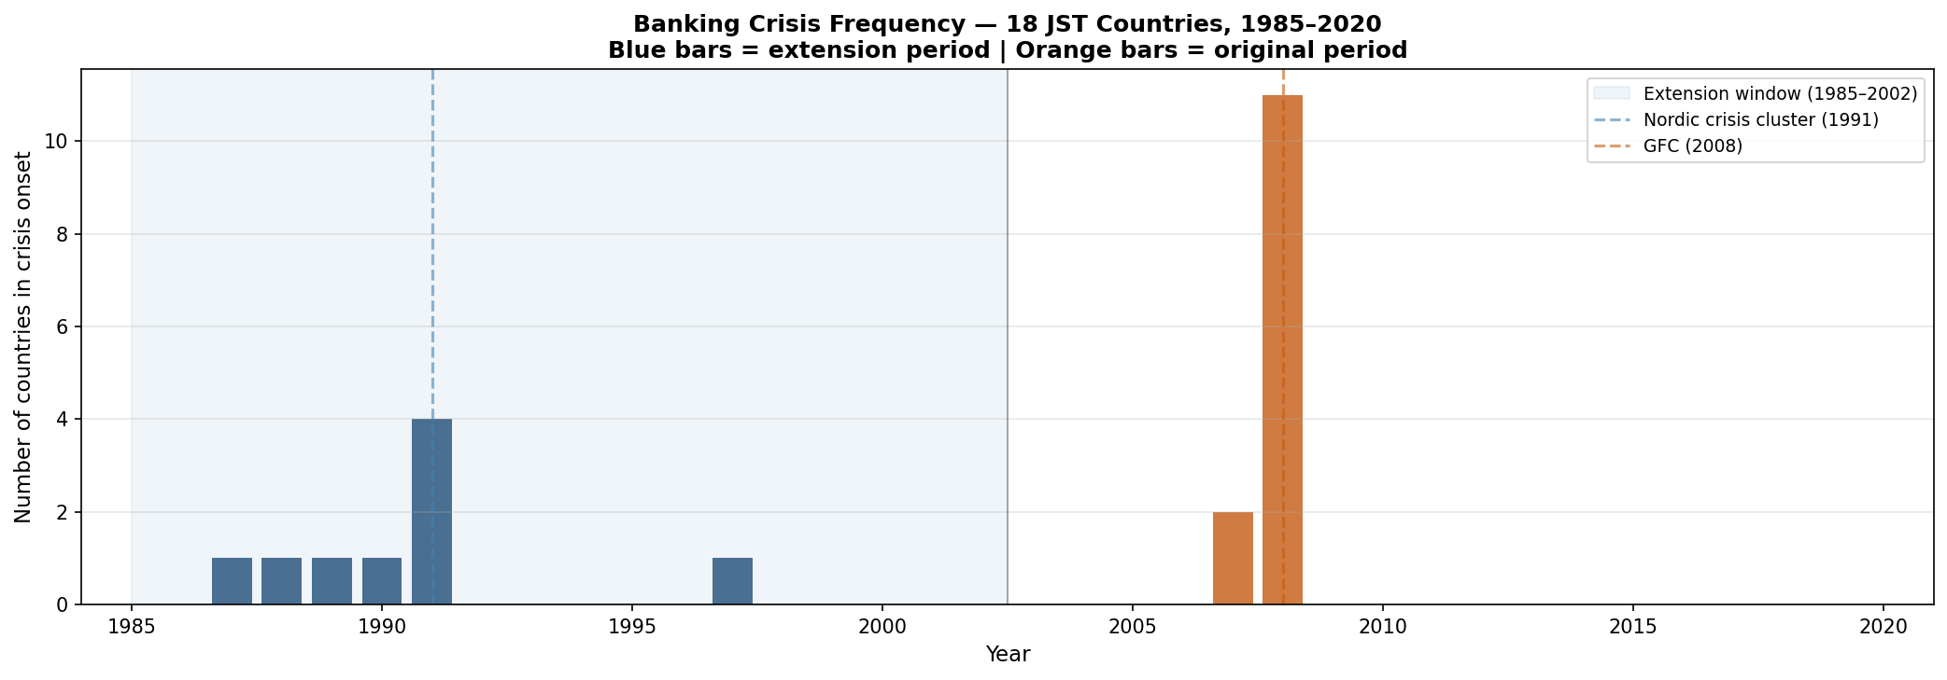
Figure A.1. Banking crisis frequency across 18 JST countries, 1985–2020. Blue bars = crisis onsets in the Stage 1 extension period (1985–2002); orange bars = onsets in the original evaluation window (2003–2020). The Nordic cluster peaks at four simultaneous onsets in 1991; the GFC episode produces 11 onsets in 2008, dominating the Stage 2 cross-sectional evaluation.

A.2 Baseline Model Analysis — Original Specification
Figures A.2–A.9 present results from the original NB04/NB06A analysis pipeline, predating the EBM M2.5 benchmark and the improved rolling-demeaned sentiment features. These serve as reference for the model development trajectory documented in Chapter 4.
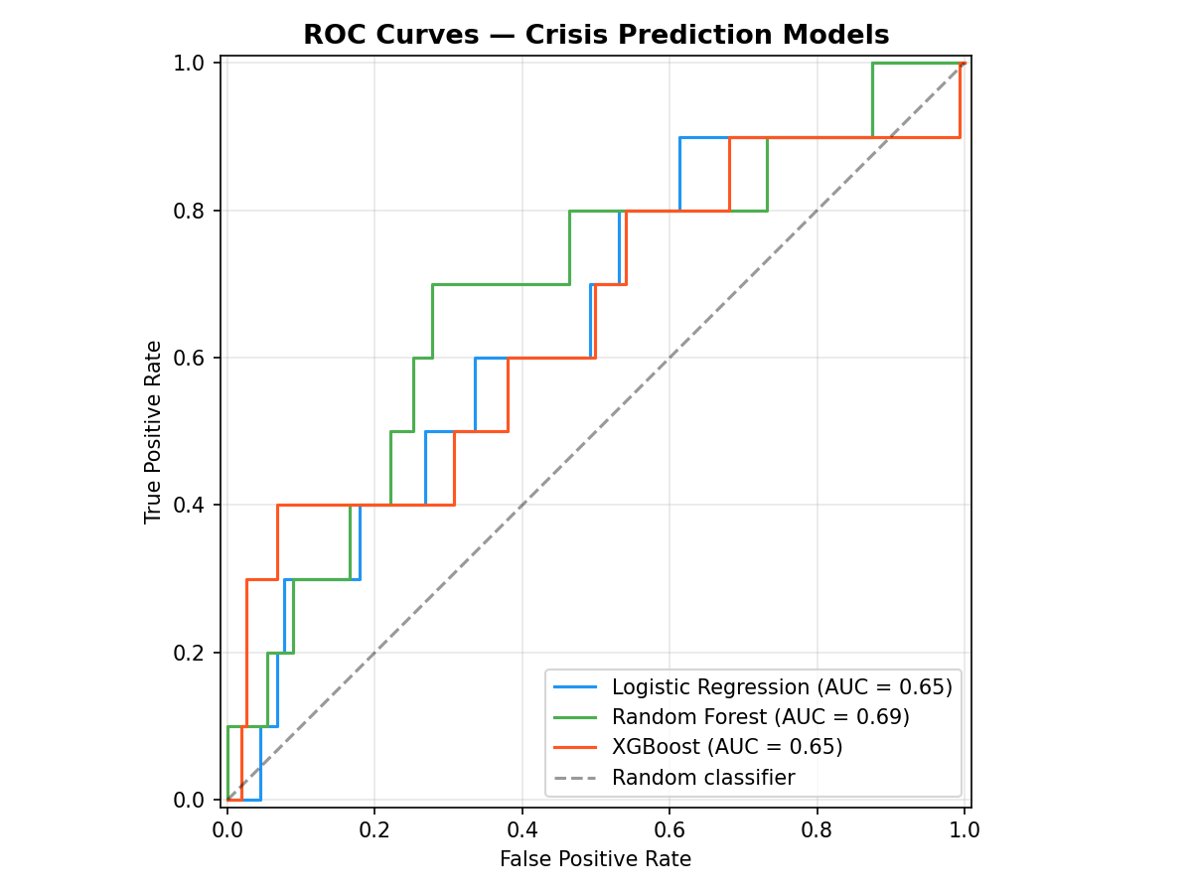
Figure A.2. ROC curves — original specification (M1 Logistic, M2 RF, M3 XGB+Sentiment). Stage 2 curves reflect the expanding-window OOS evaluation prior to the EBM extension. Compare Figure 4.1, which adds the EBM M2.5 benchmark.
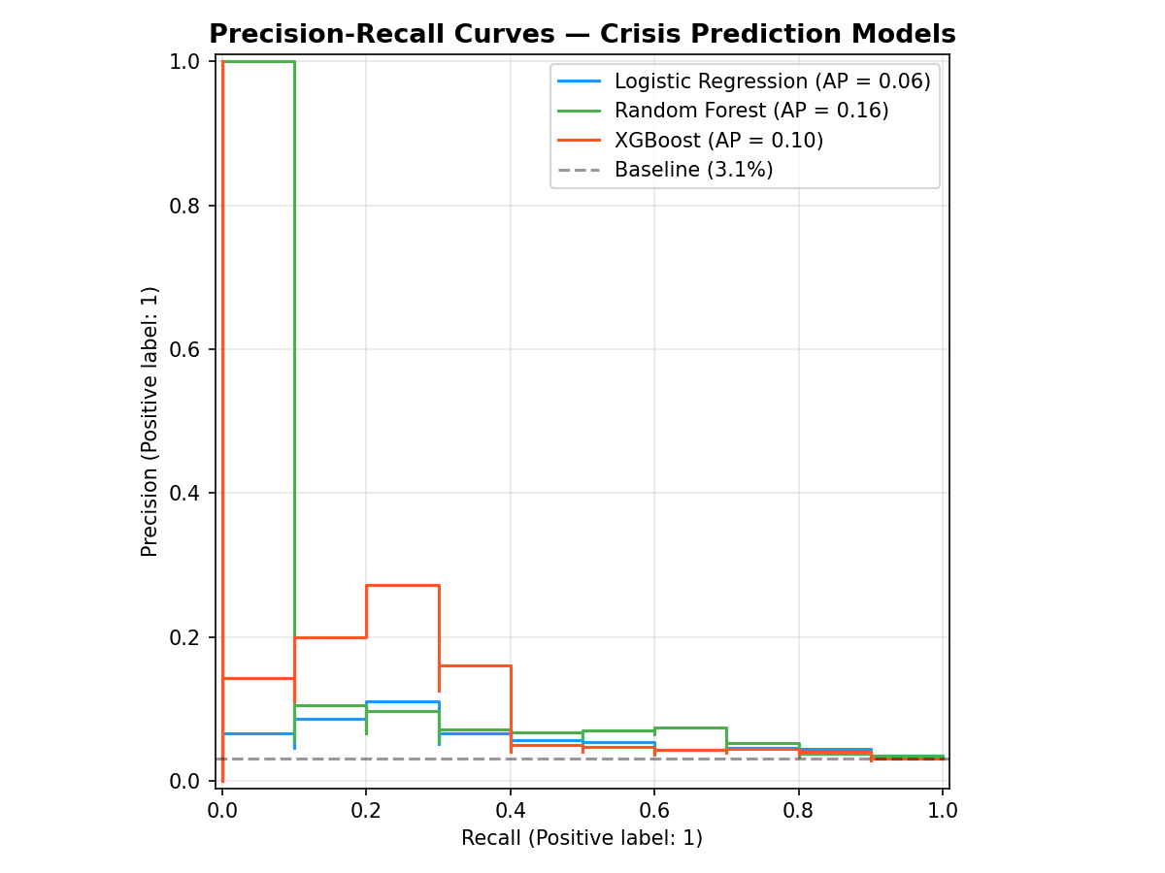
Figure A.3. Precision-Recall curves — original specification. Under class imbalance (base rate ~8%), AUPRC is the primary discrimination metric. These results predate the improved feature engineering in the augmented analysis.
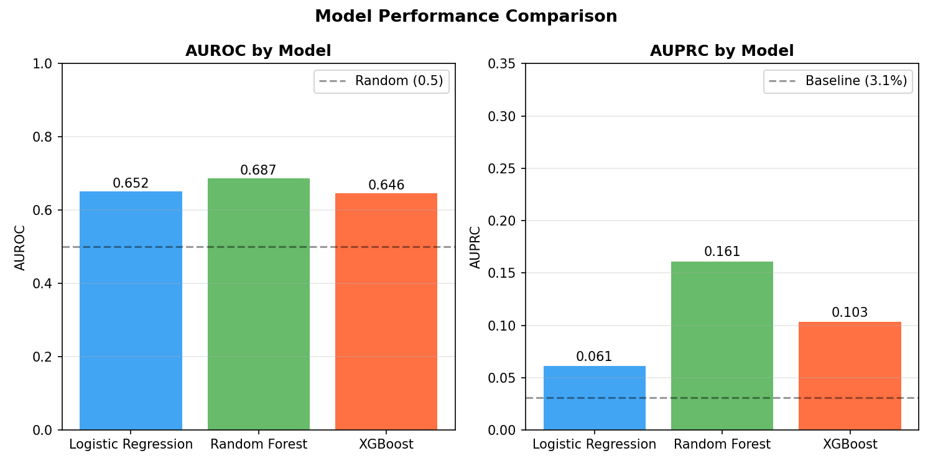
Figure A.4. Performance comparison summary — original specification. AUROC and AUPRC across M1, M2, and M3 for the primary evaluation window. Used as a reference baseline prior to EBM integration.
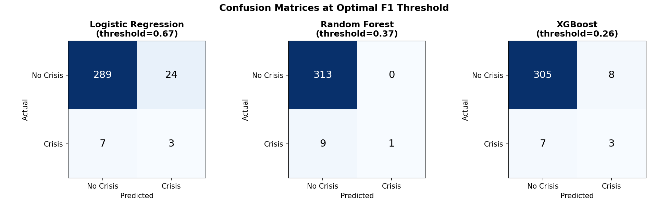
Figure A.5. Confusion matrices at optimal threshold — M1 Logistic, M2 RF, M3 XGB+Sentiment, original specification. Illustrates the precision-recall trade-off at the F1-maximising classification threshold for each model.
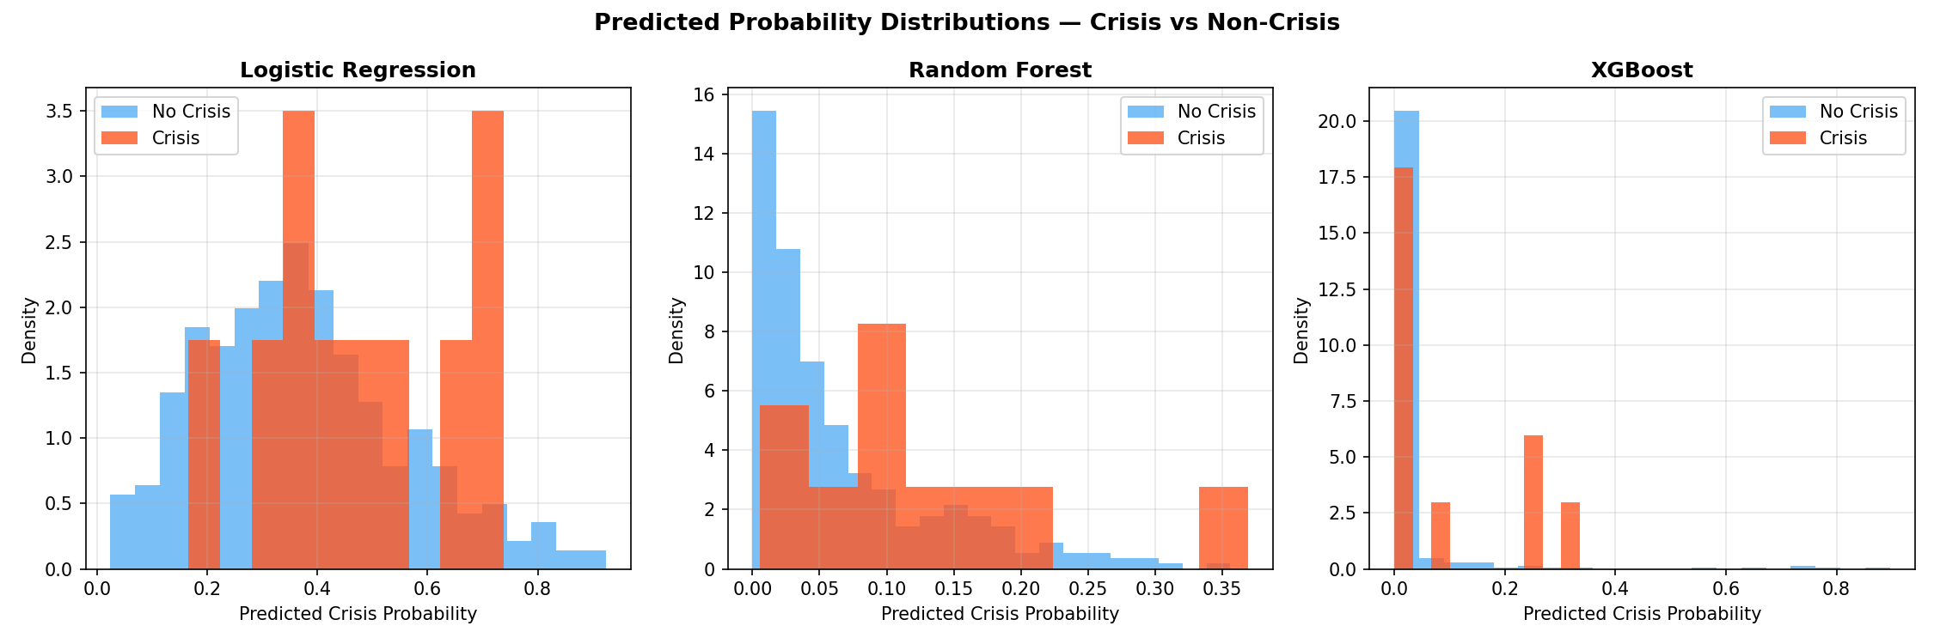
Figure A.6. Out-of-sample crisis probability distributions — original specification. Probability histograms for crisis (positive) and non-crisis (negative) observations, showing model separation characteristics. Better-separated distributions indicate higher discriminative power.
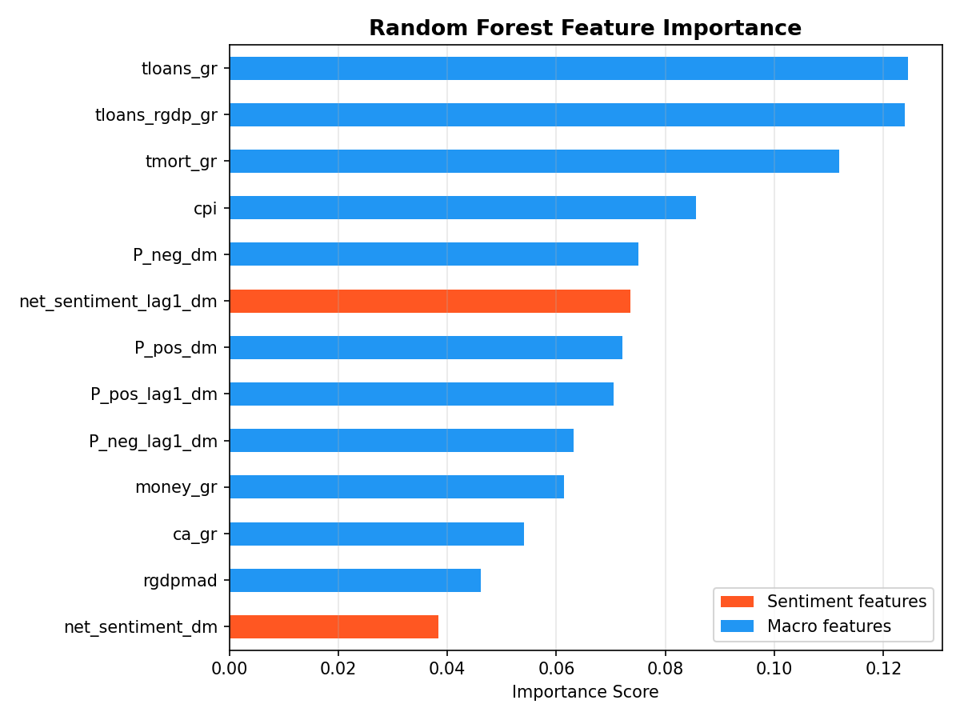
Figure A.7. Random Forest M2 feature importance — original specification. Mean decrease in impurity across all trees. Term spread and credit growth features dominate, consistent with the SHAP and EBM attribution in Figures 4.5 and 4.6.
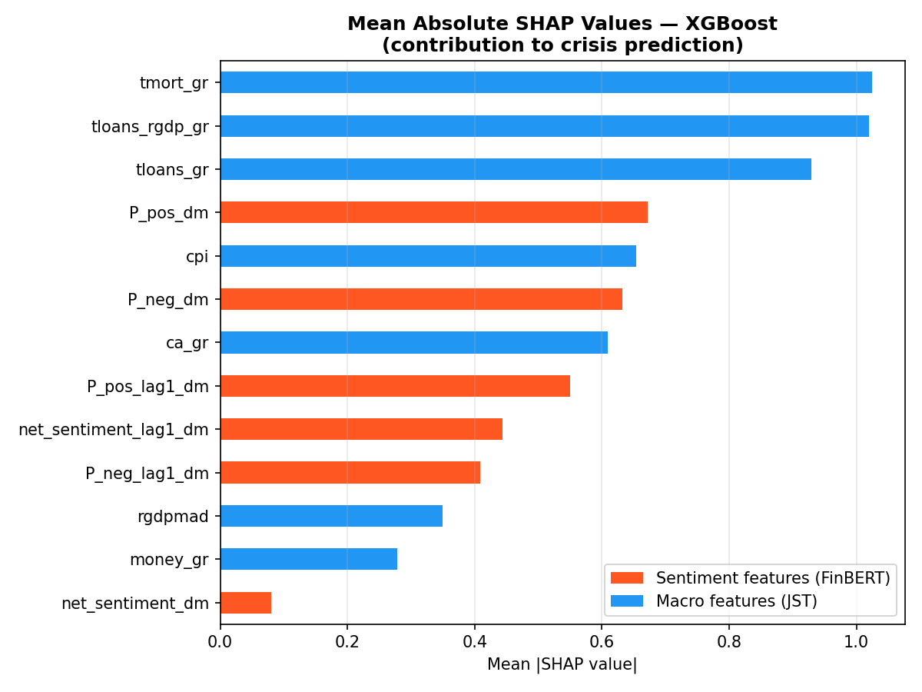
Figure A.8. SHAP mean absolute values — M3 XGB+Sentiment, original specification. Macro features contribute the majority of attribution; this earlier specification uses static demeaning rather than the rolling-mean approach adopted in the augmented analysis.
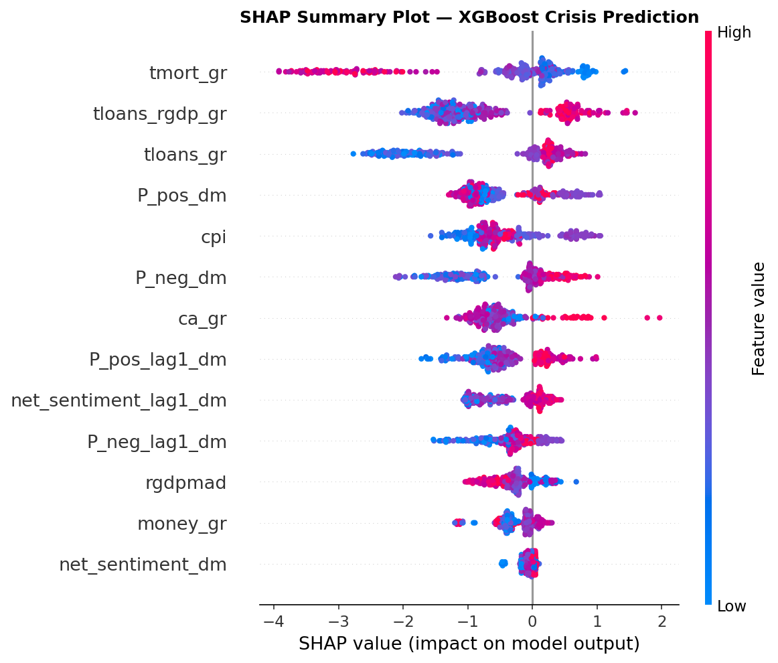
Figure A.9. SHAP summary plot — M3 original specification. Feature ranking by mean |SHAP| with directional contribution (positive/negative). Term spread features dominate at all lag horizons; sentiment features appear at lower ranks, consistent with the augmented analysis results.
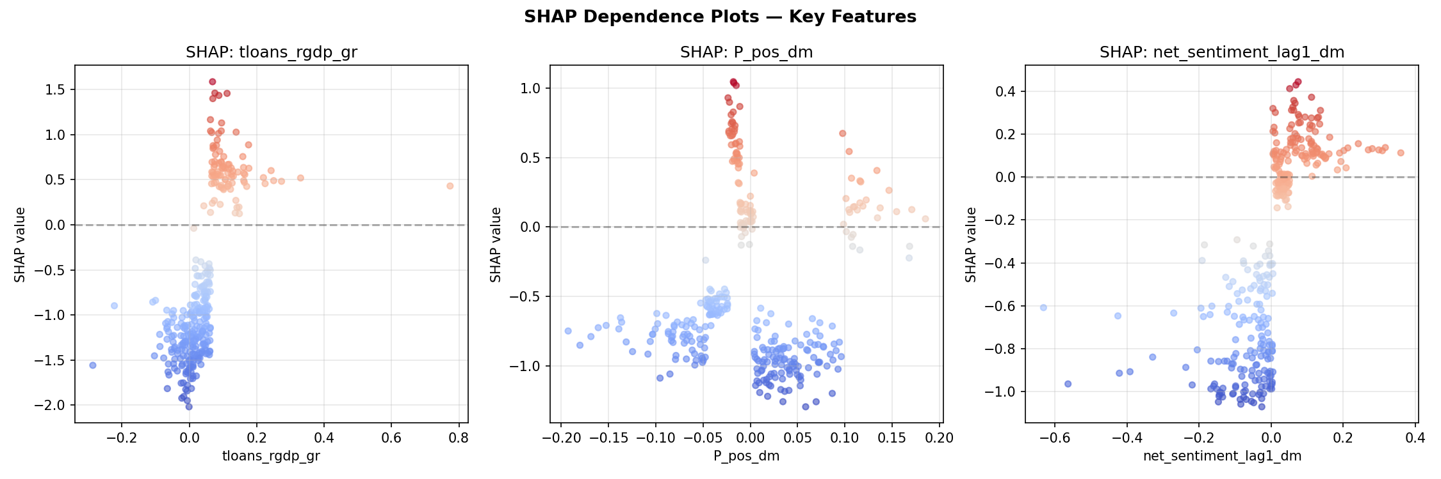
Figure A.10. SHAP dependence plots — selected macro features, M3 original specification. Each panel shows the SHAP value for one feature against its raw value, with colour encoding the most interacting feature. Non-linear and cross-feature interactions are visible for term spread and credit growth.

A.3 Pre-EBM Augmented Analysis
Figures A.10–A.12 reproduce key outputs from the augmented analysis before the EBM M2.5 benchmark was incorporated (NB05A/NB06A stage). They document the intermediate state of the model comparison and SHAP attribution.
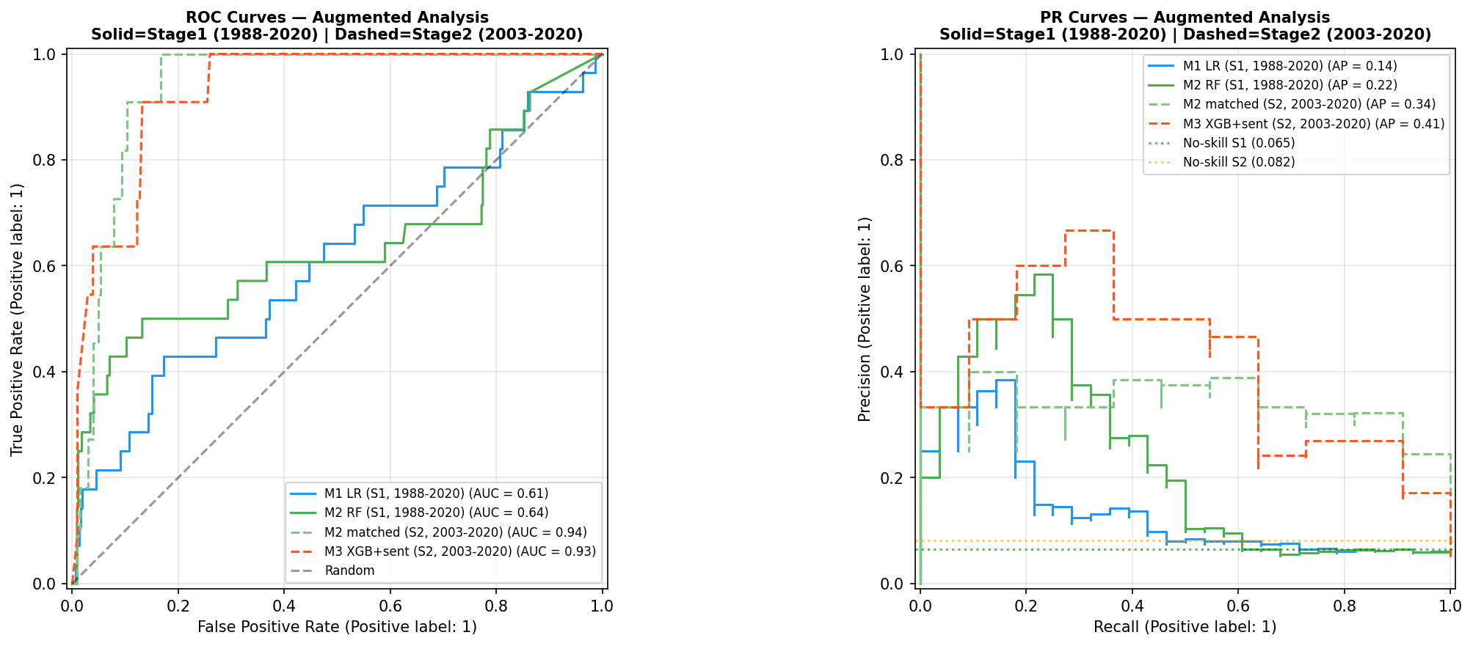
Figure A.11. ROC and PR curves — augmented analysis, pre-EBM specification. Solid = Stage 1 (1988–2020), dashed = Stage 2 (2003–2020). Models shown: M1 LR, M2 RF, M2-matched, M3 XGB+Sentiment. This figure corresponds to the analysis before EBM M2.5 was introduced; Figure 4.1 adds EBM M2.5 as the interpretable non-linear benchmark.
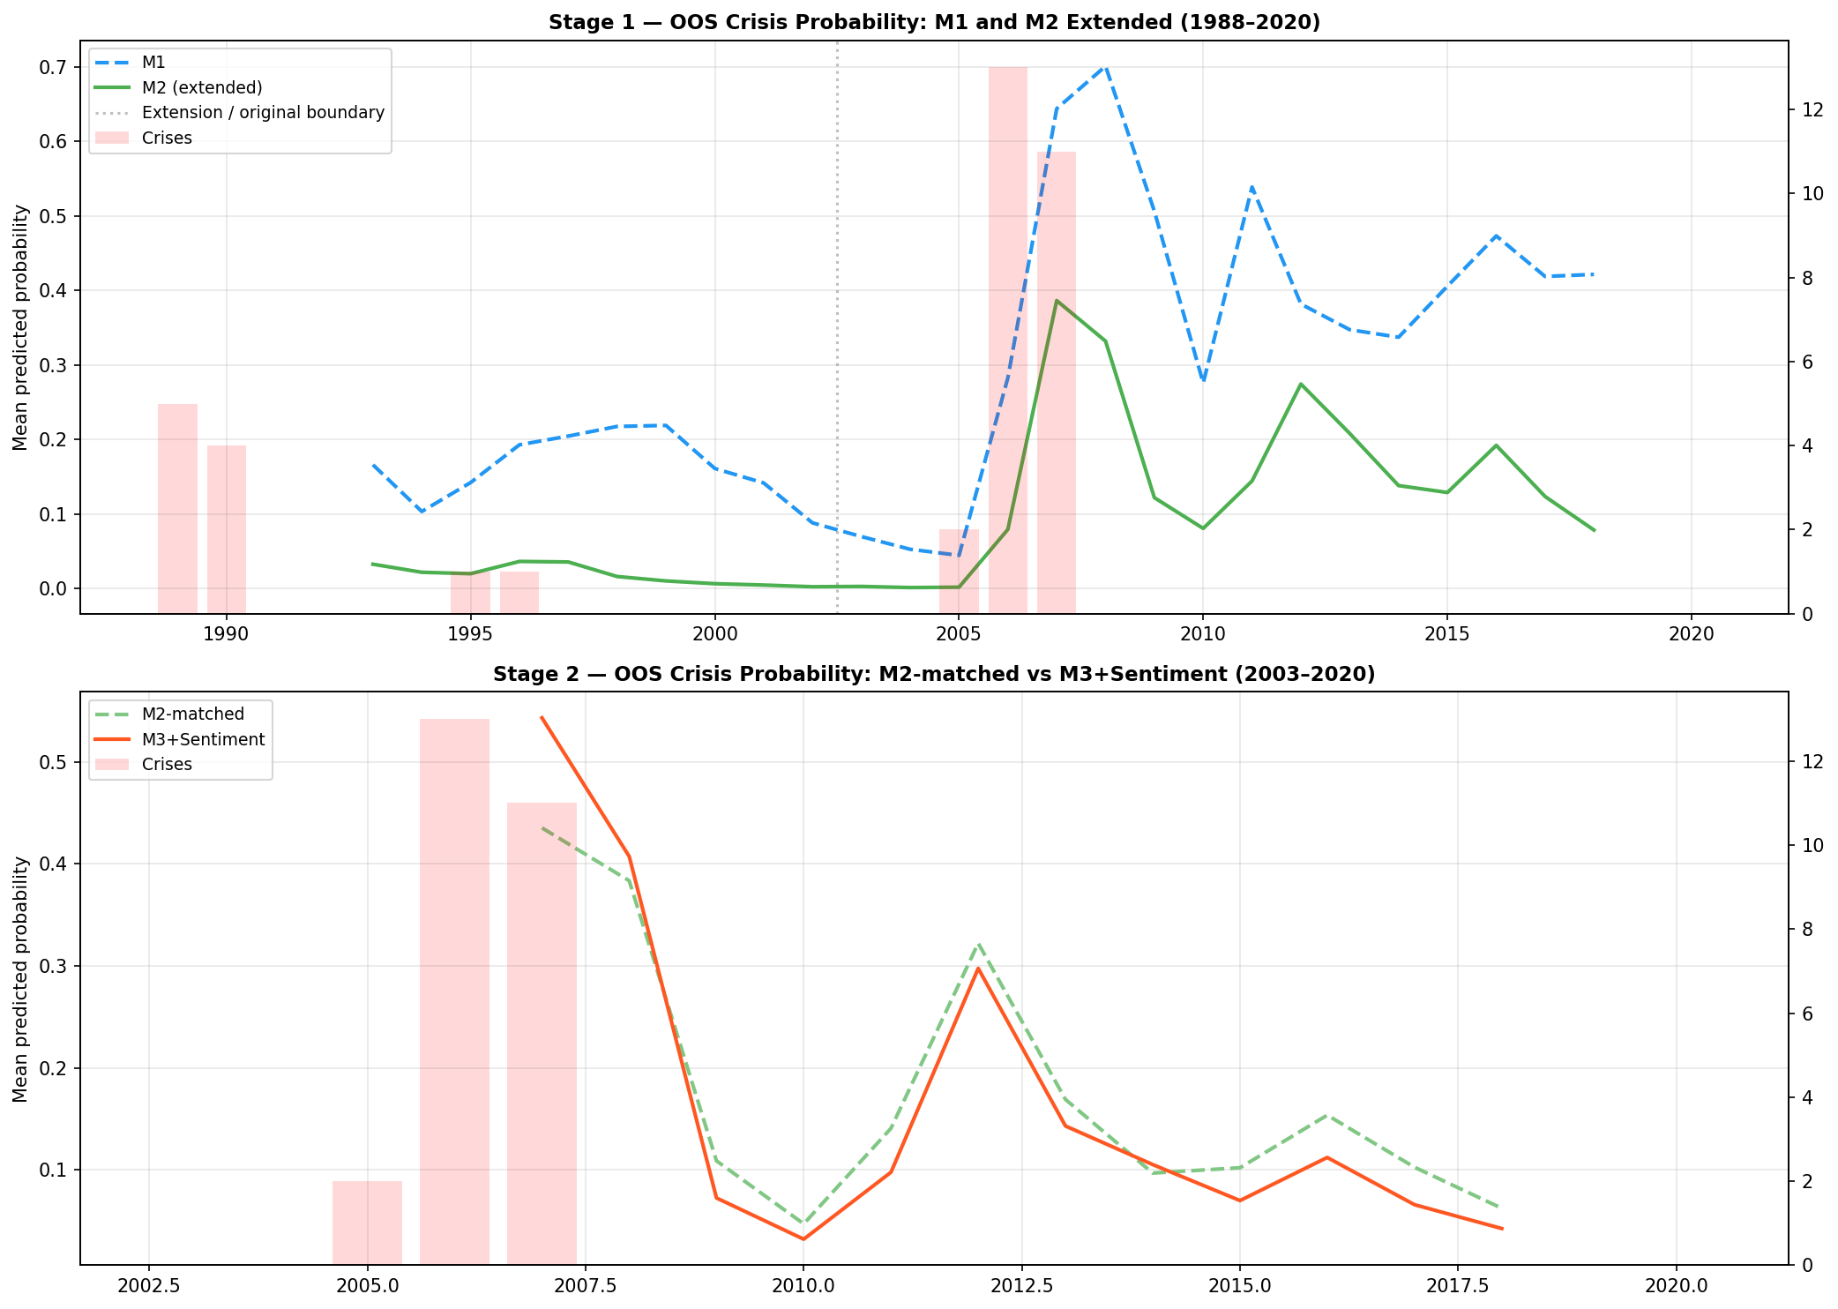
Figure A.12. Out-of-sample crisis probability over time — pre-EBM specification. Stage 1 (top): M1 LR and M2 RF extended to 1988–2020. Stage 2 (bottom): M2-matched versus M3+Sentiment. Compare Figure 4.2, which adds EBM M2.5 trajectories and shows the EBM’s sharper GFC peak relative to M2 RF.
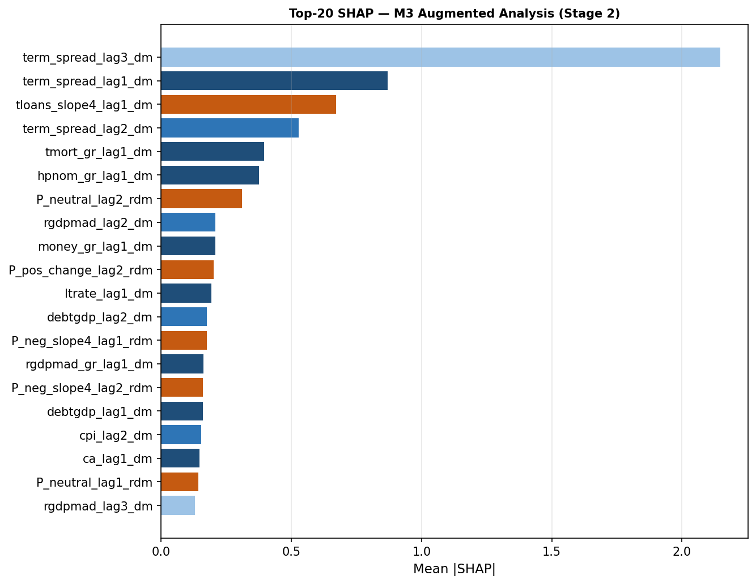
Figure A.13. Top-20 SHAP features — M3 augmented analysis, Stage 2. Blue = macro features; orange = FinBERT rolling-demeaned sentiment. Term spread at lag 3 dominates (mean |SHAP| = 2.17); sentiment features (P_neutral_lag2, P_pos_change_lag2, P_neg_slope4) appear in the top 20 but at substantially lower importance than term spread and loan growth variables.

A.4 Model Identification and Robustness Checks
Figures A.13–A.15 present robustness analyses from the NB08B/robustness pipeline, decomposing performance drivers and stress-testing temporal generalisability.
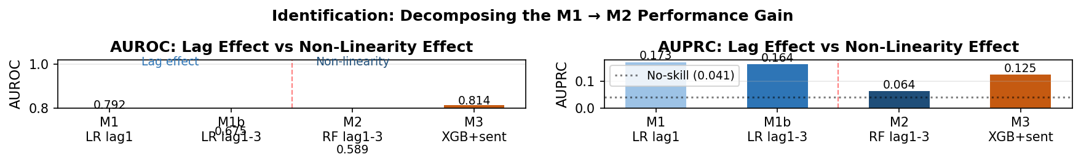
Figure A.14. Decomposing the M1→M2 performance gain: lag effect versus non-linearity. Left: AUROC. Right: AUPRC. M1b (LR, lags 1–3) isolates the lag extension effect relative to M1 (LR, lag 1 only); M2 RF isolates non-linearity given the same three lags. The AUPRC pattern shows the lag effect is modest; M3 XGB+Sentiment recovers performance through non-linear modelling and sentiment augmentation.
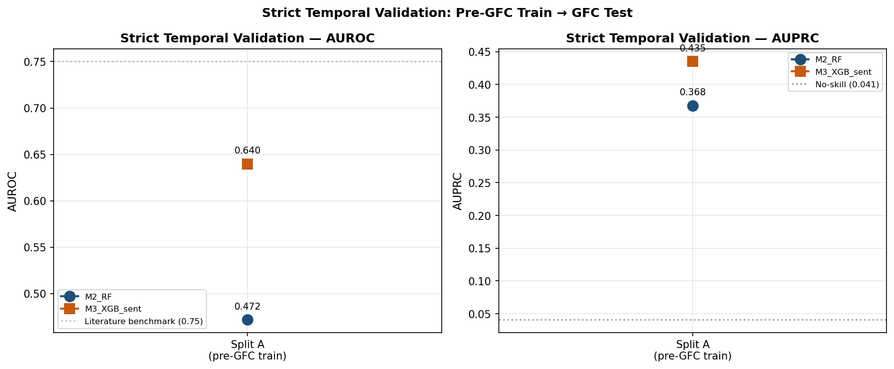
Figure A.15. Strict temporal validation: pre-GFC training window (Split A) → GFC test. AUROC (left) and AUPRC (right) for M2 RF (blue) and M3 XGB+Sentiment (orange). Both models fail the 0.75 AUROC literature benchmark; M3 achieves AUROC = 0.640, M2 achieves 0.472. Consistent with the EBM Split B result (Section 4.5), no model trained exclusively on pre-GFC data generalises prospectively to the GFC test window.
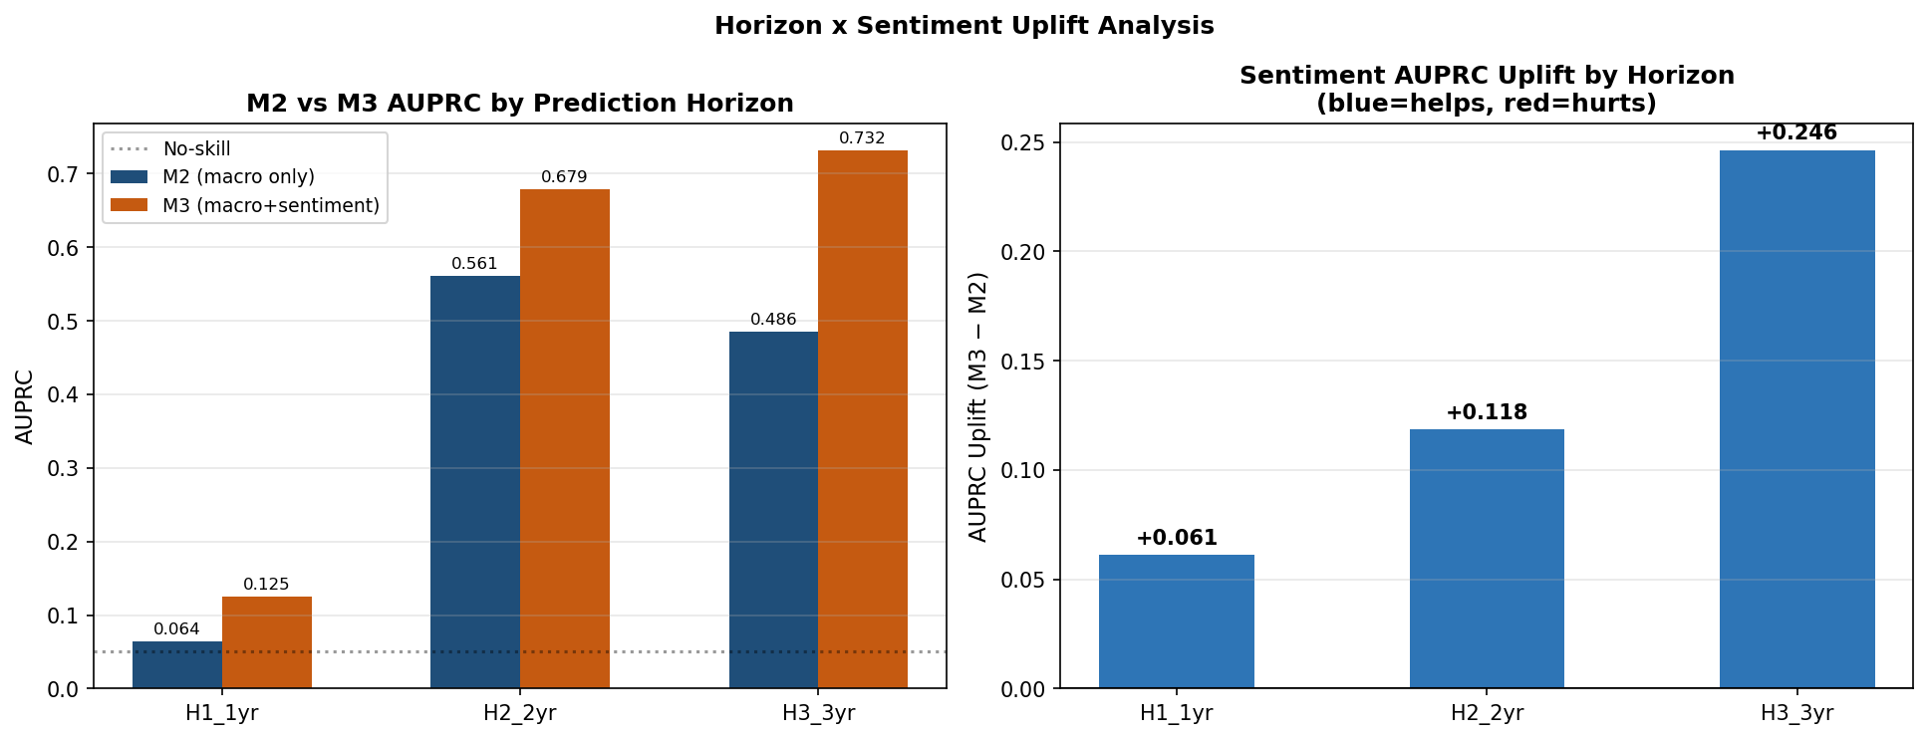
Figure A.16. Sentiment AUPRC uplift by prediction horizon. Left: M2 (macro-only) vs M3 (macro+sentiment) AUPRC at H1 (1-year), H2 (2-year), and H3 (3-year) targets. Right: absolute uplift M3−M2. Sentiment uplift grows monotonically from +0.061 at H1 to +0.246 at H3, suggesting a longer-horizon precautionary signal in central bank speech. These horizons were excluded from the primary pipeline due to insufficient test events in 2016–2020 (Section 4.8).

A.5 EBM Shape Function Analysis — Supplementary
Figure A.16 provides a simplified two-feature view of EBM shape function instability, complementing the six-panel display in Figure 4.7.
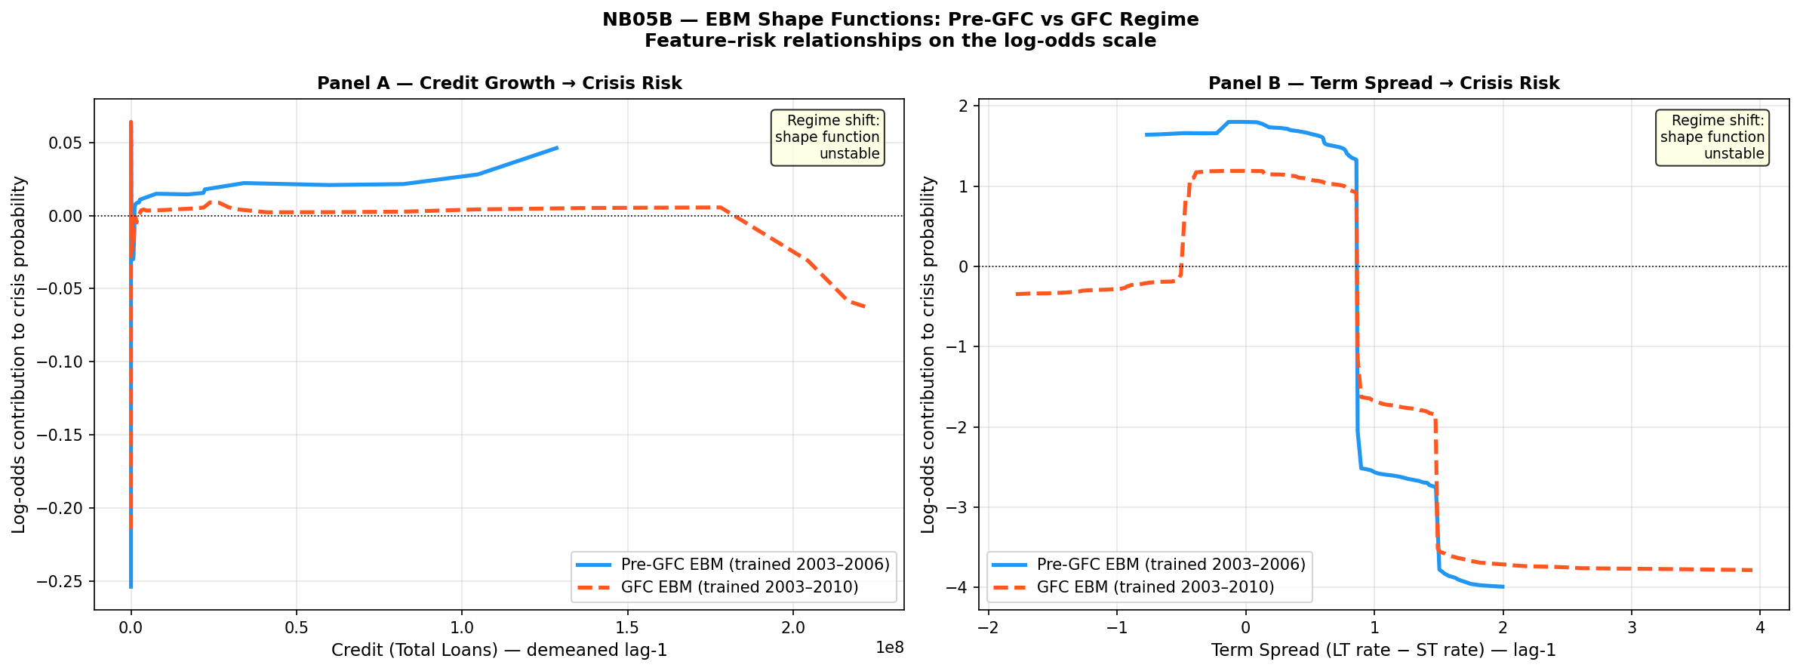
Figure A.17. EBM shape functions for credit growth (Panel A, lag 1) and term spread (Panel B, lag 1): Pre-GFC EBM (blue solid, trained 2003–2006) vs GFC-inclusive EBM (red dashed, trained 2003–2010). Both panels confirm regime instability: term spread contributions reverse sign at moderate positive values across regimes; credit growth shifts from near-zero to increasingly negative contributions at high values in the GFC window. Annotation boxes confirm the shape function instability interpretation. Simplified view of Figure 4.7.

A.6 Sentiment Analysis — Additional Results (sentiment_improved Specification)
Figures A.17–A.26 present the full output of the sentiment_improved pipeline, which replaces static mean-demeaning with rolling-window momentum and trend features to reduce data-leakage risk in the sentiment signal construction.
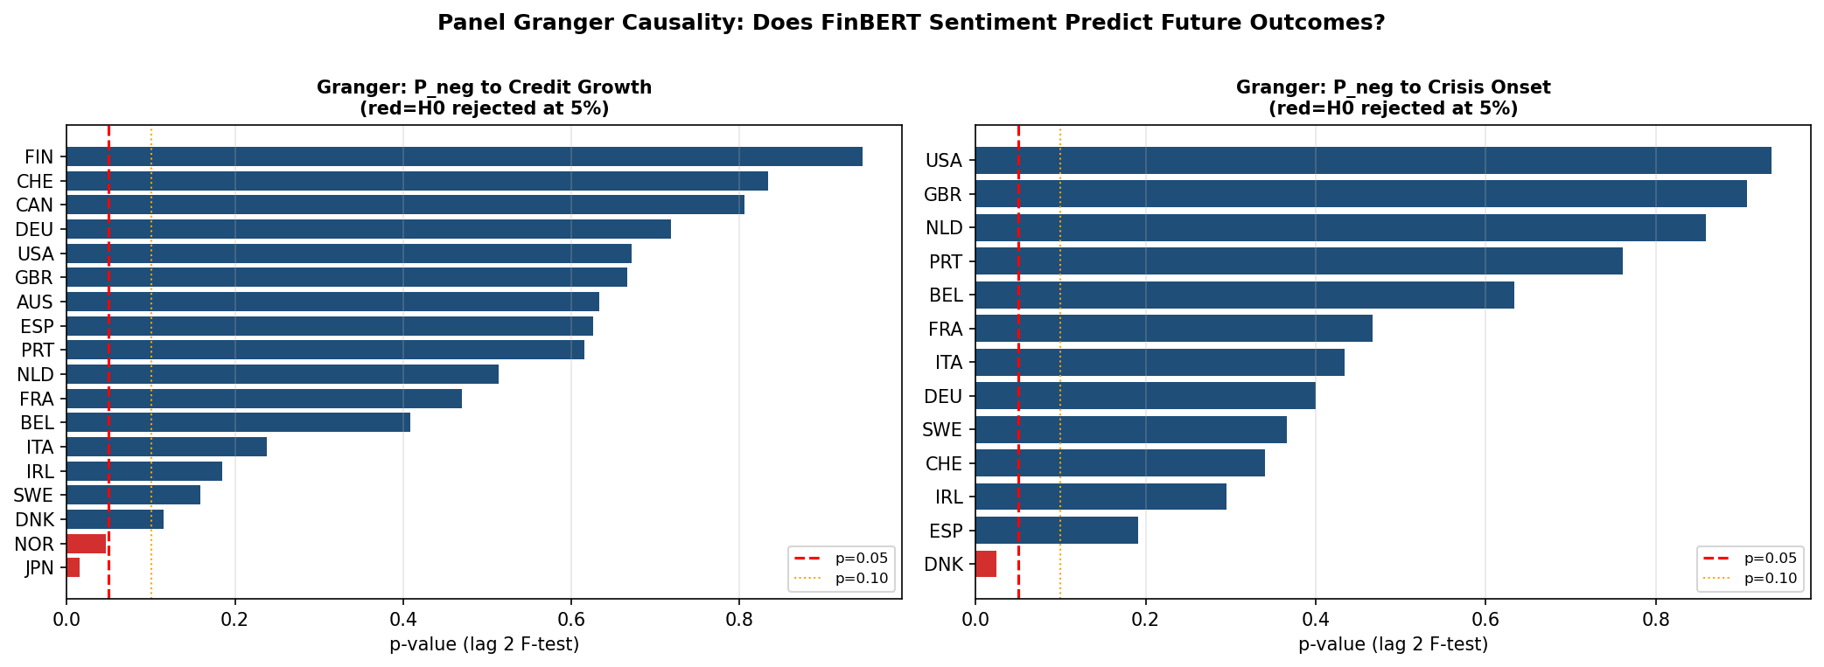
Figure A.18. Panel Granger causality tests: FinBERT P_neg → credit growth (left) and → crisis onset (right), lag-2 F-test p-values for 18 countries. Red dashed line = p = 0.05; orange dotted = p = 0.10. Sentiment significantly Granger-causes credit growth in Japan and Norway only; no country reaches significance for the crisis onset target. These results support the conclusion that FinBERT sentiment does not carry a systematic country-level predictive signal ahead of banking crises (Section 4.9).
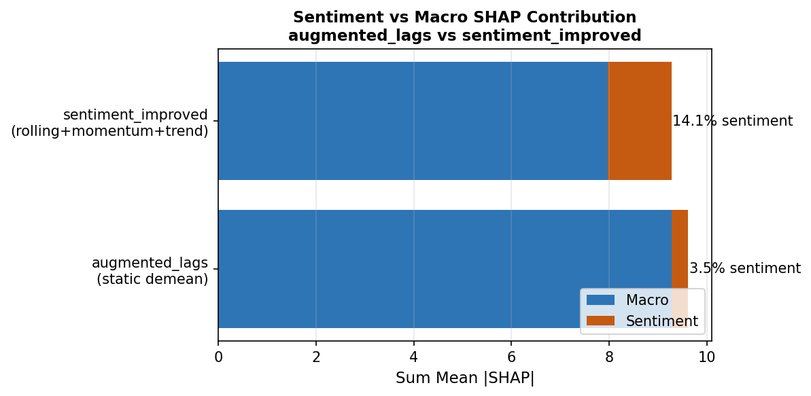
Figure A.19. Macro vs sentiment SHAP contribution: augmented_lags (static demeaning, 3.5% sentiment) versus sentiment_improved (rolling+momentum+trend, 14.1% sentiment). Improving the sentiment feature engineering quadruples the sentiment share of total SHAP attribution, though macro features remain dominant in both specifications.
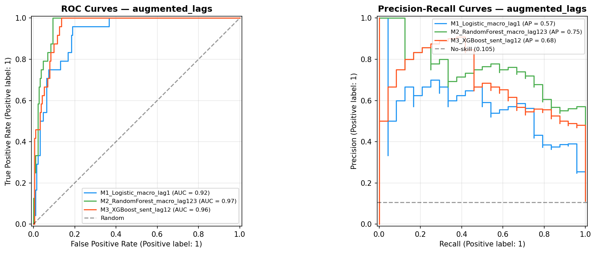
Figure A.20. ROC and PR curves — sentiment_improved specification. M1 Logistic (blue), M2 RF (green), M3 XGBoost+Sentiment rolling (orange). Stage 2 AUPRC for M3 improves to 0.63 compared to 0.41 in the primary augmented analysis, reflecting the improved rolling sentiment engineering. Stage 2 AUROC remains broadly comparable.
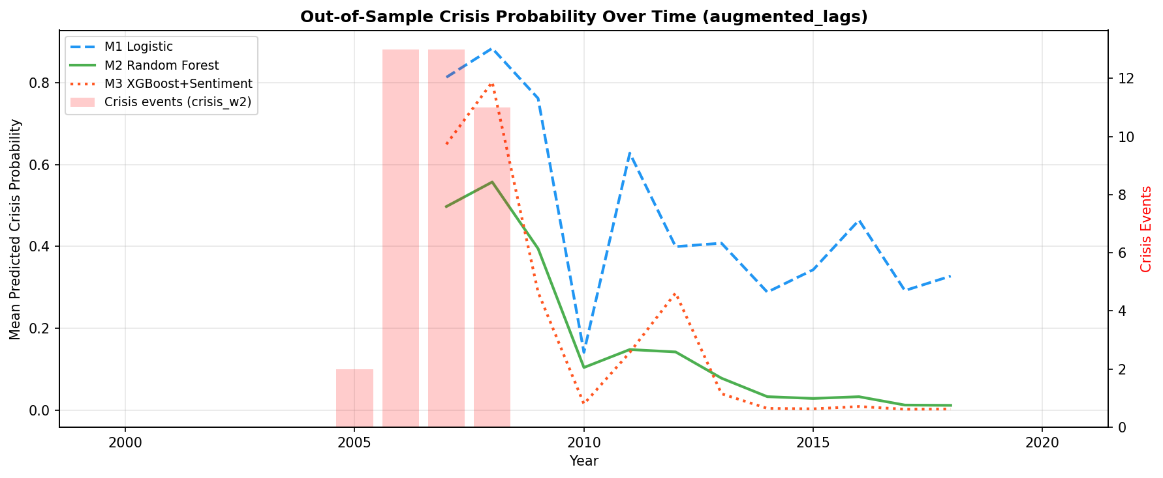
Figure A.21. Out-of-sample crisis probability over time — sentiment_improved specification. M1 LR (blue dashed), M2 RF (green solid), M3+Sentiment (red dotted). The rolling sentiment specification produces a sharper GFC peak (M3 reaching 0.62 in 2007–2008) compared to the primary analysis, but post-crisis persistence and false positives in 2010–2015 remain.
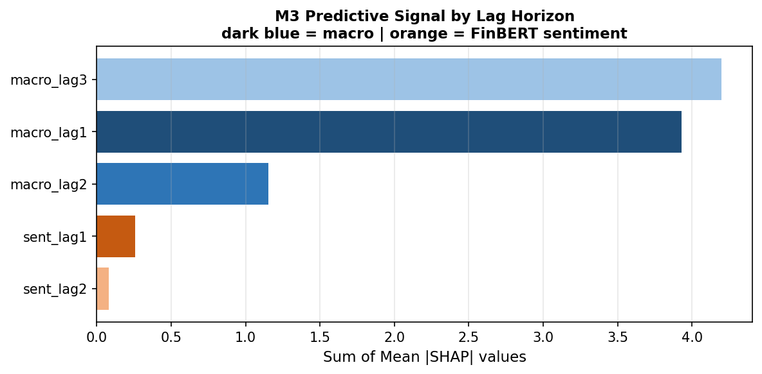
Figure A.22. M3 SHAP signal by lag horizon — sentiment_improved, rolling+momentum+trend variant. Macro lag 3 (4.2 units) and lag 1 (2.9 units) dominate; sentiment at lag 1 contributes approximately 1.0 units, ranking third. Macro features account for approximately 86% of total attribution in this variant.
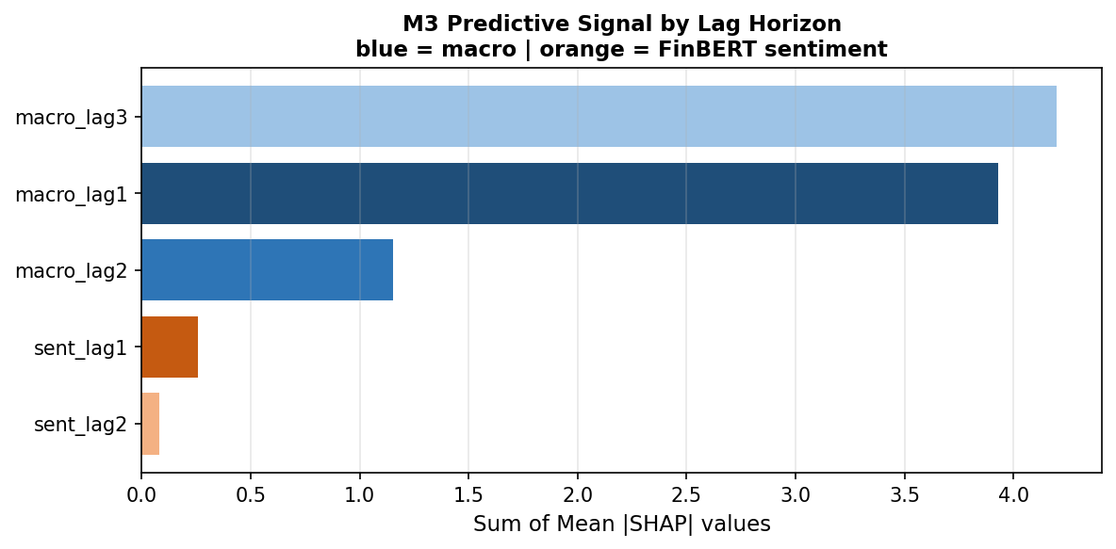
Figure A.23. M3 SHAP signal by lag horizon — sentiment_improved, rolling-demeaned variant. Sentiment contribution at lag 1 is reduced to 0.3 units (vs 1.0 in Figure A.21), demonstrating sensitivity of the sentiment SHAP share to the specific demeaning approach. Macro features account for approximately 94% of total attribution in this variant.
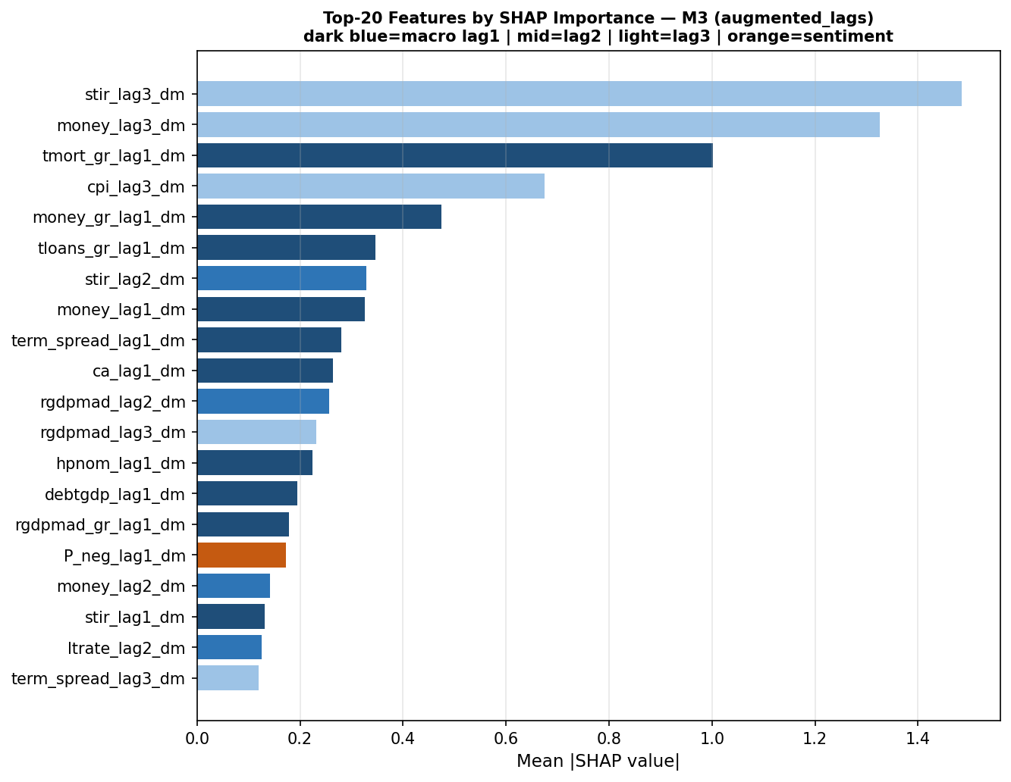
Figure A.24. Top-20 SHAP features — M3 sentiment_improved specification. Term spread at lag 3 remains the dominant individual feature (mean |SHAP| = 1.87). The feature set shifts relative to the augmented analysis (Figure A.12): stir_lag1, rgdpmad_lag3, and ltrate_lag3 enter the top five, while only one sentiment feature (P_neg_roll3_std_lag1) appears, at rank 20.
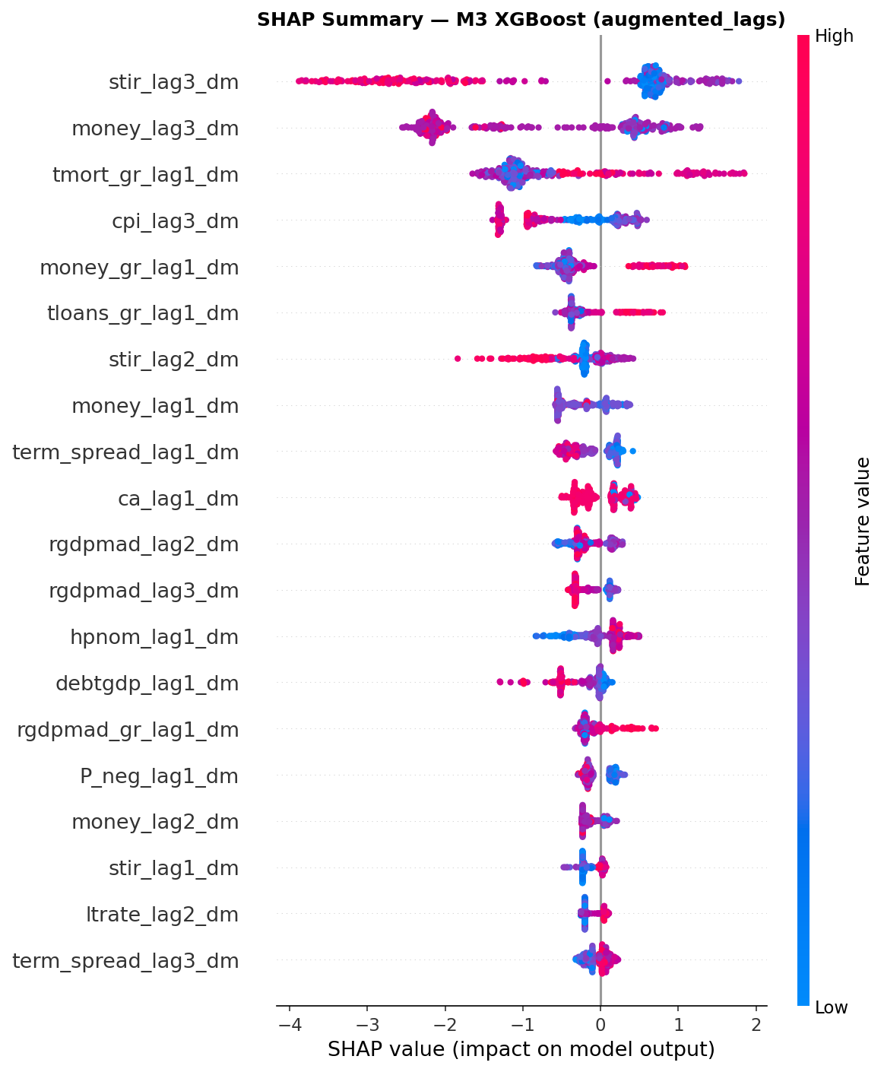
Figure A.25. SHAP beeswarm plot — M3 sentiment_improved. Each point = one observation; colour = feature value (red=high, blue=low). Term spread lag 3 shows the most complex pattern, with both high and low values generating large negative contributions — consistent with the non-monotonic EBM shape functions in Figure 4.7. Credit features show predominantly positive contributions at high values in this specification.
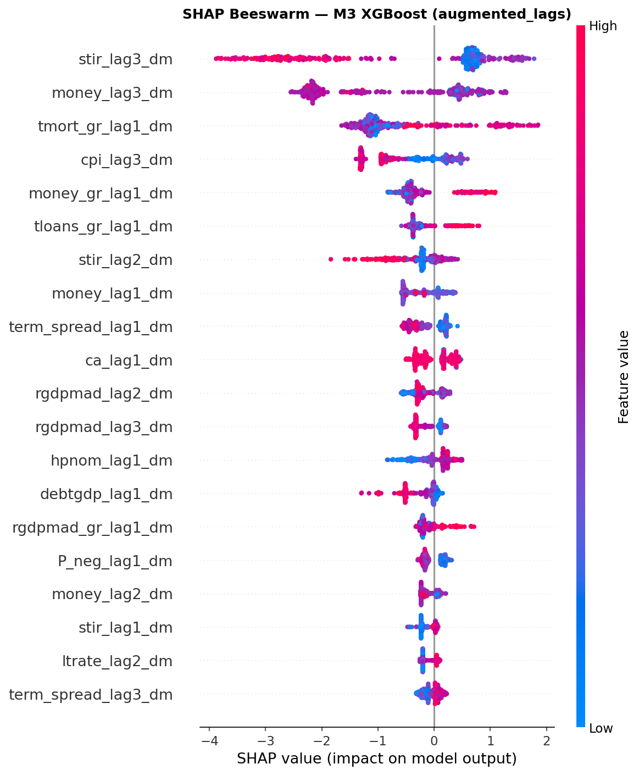
Figure A.26. SHAP beeswarm plot — M3 alternative specification. Feature ranking and directional contributions for the second beeswarm variant; compare Figure A.25 for the sentiment_improved configuration. Term spread features dominate at all lag horizons.
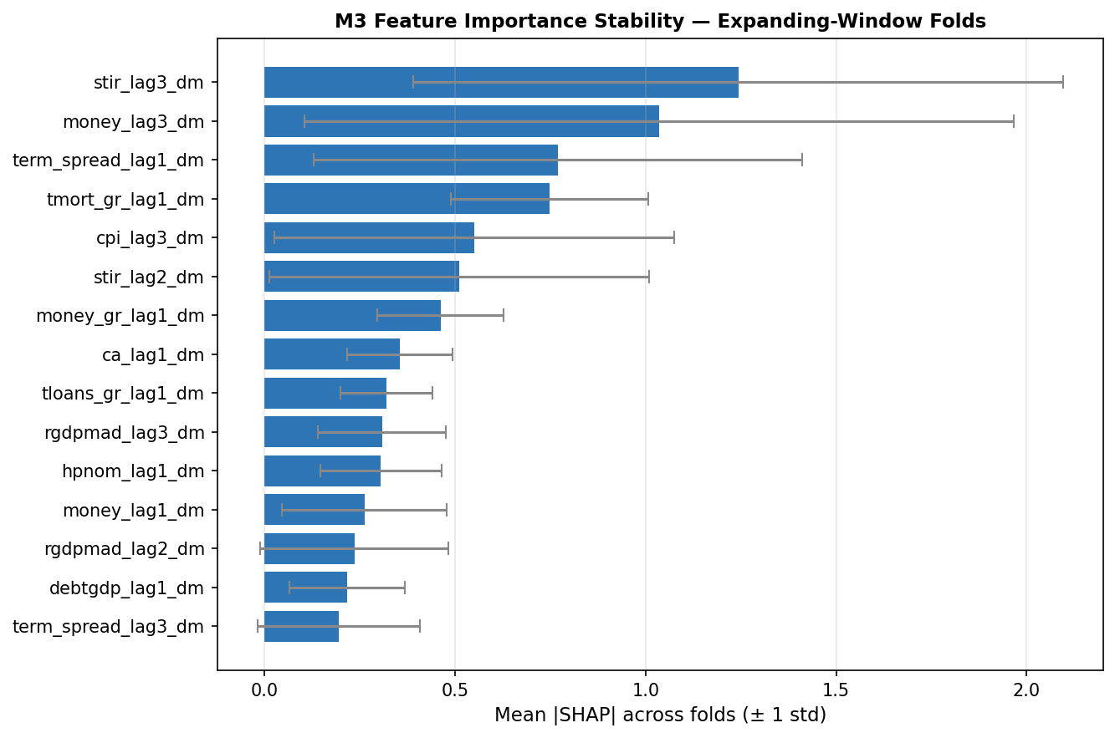
Figure A.27. M3 feature stability across expanding-window folds — sentiment_improved specification (mean ± 1 std across folds). Term spread lags 1 and 3 show the highest mean importance but also the widest confidence intervals, reflecting fold-to-fold variation consistent with the structural non-stationarity thesis of Chapter 4. Sentiment features are absent from the top-15 stable features.

A.7 Calibration and Decision-Threshold Analysis
Figures A.27–A.29 provide additional calibration diagnostics and threshold sensitivity analysis to complement Figure 4.8.
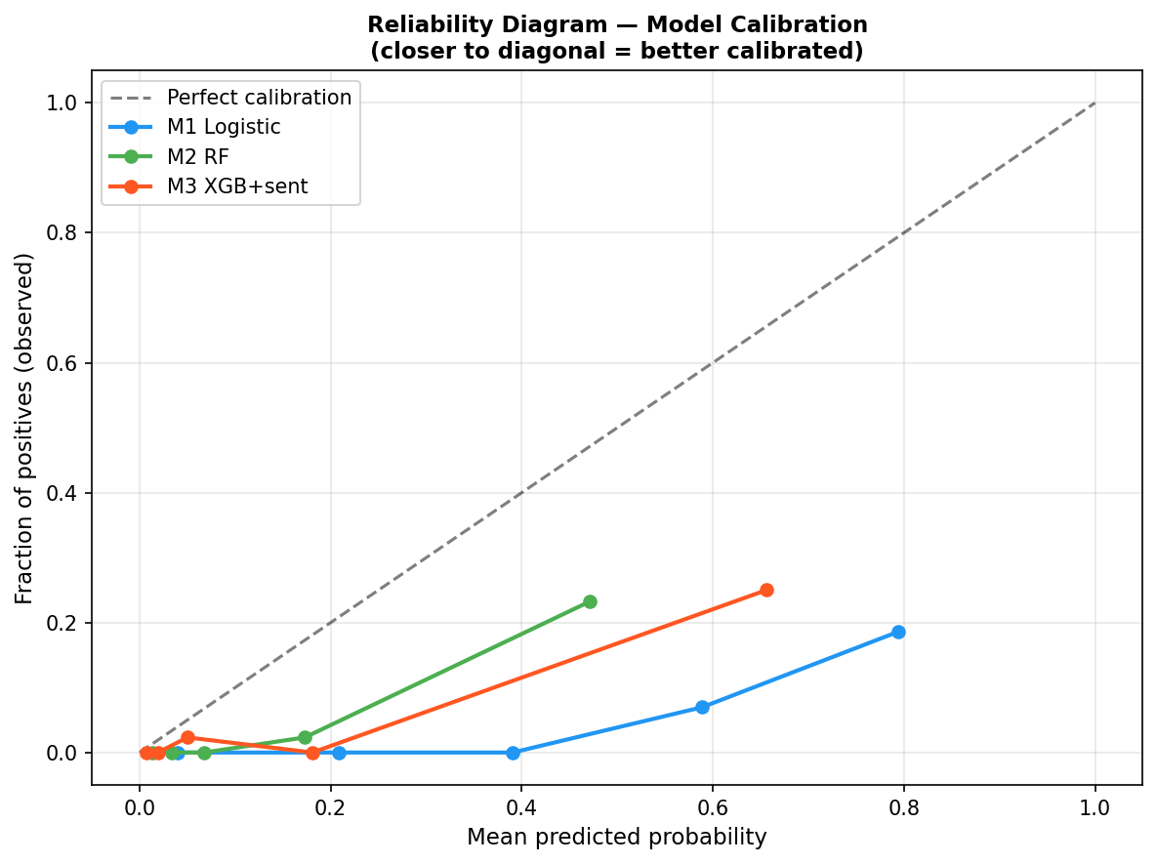
Figure A.28. Reliability diagram — M1 Logistic, M2 RF, M3 XGB+Sentiment, original specification. All three models exhibit systematic under-confidence: predicted probabilities understate observed crisis frequency at higher probability bins. M2 and M3 show steeper improvement over M1 but remain well below the perfect calibration diagonal. Compare Figure 4.8, which shows the Stage 2 models (M2-matched, EBM M2.5, M3) with EBM achieving ECE = 0.084.
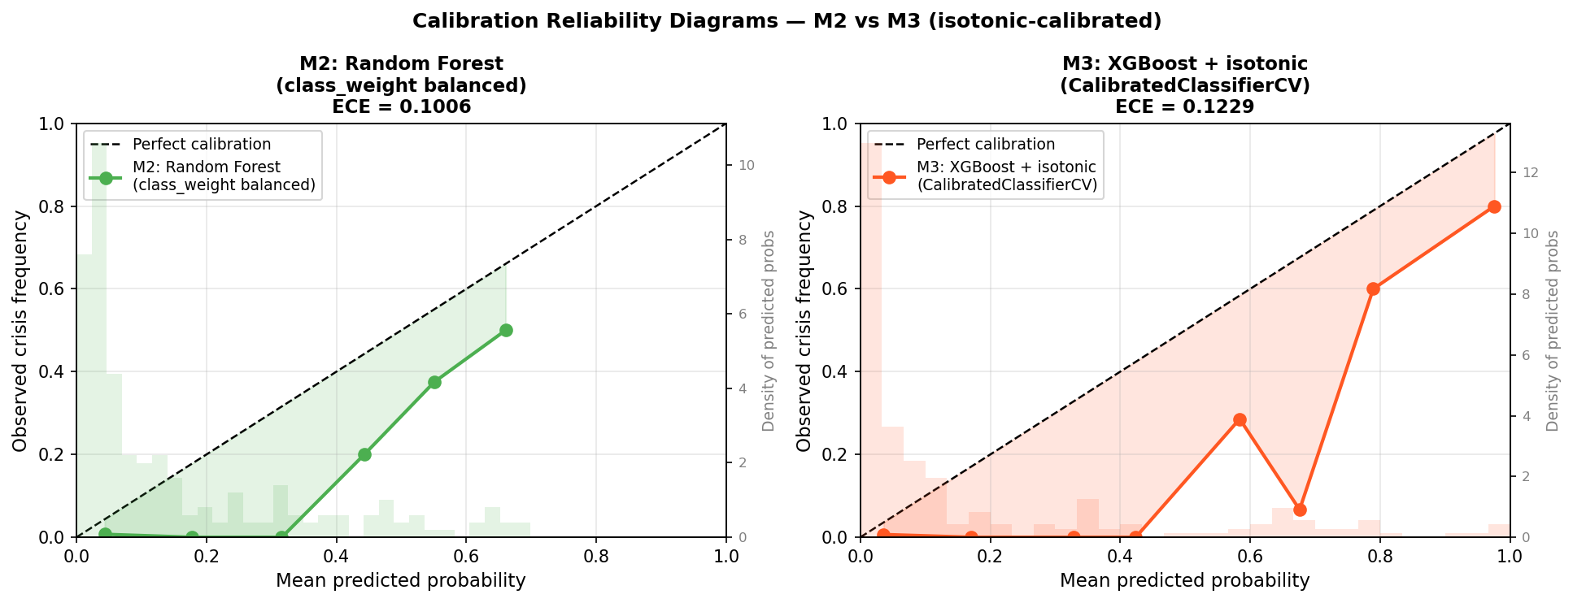
Figure A.29. Calibration reliability diagrams with isotonic correction — M2 RF (left, ECE = 0.101) and M3 XGBoost+isotonic (right, ECE = 0.123). Under CalibratedClassifierCV, M2 RF achieves better ECE than M3 after isotonic correction. The EBM M2.5 in Figure 4.8 achieves ECE = 0.084 without isotonic calibration, confirming its calibration advantage.
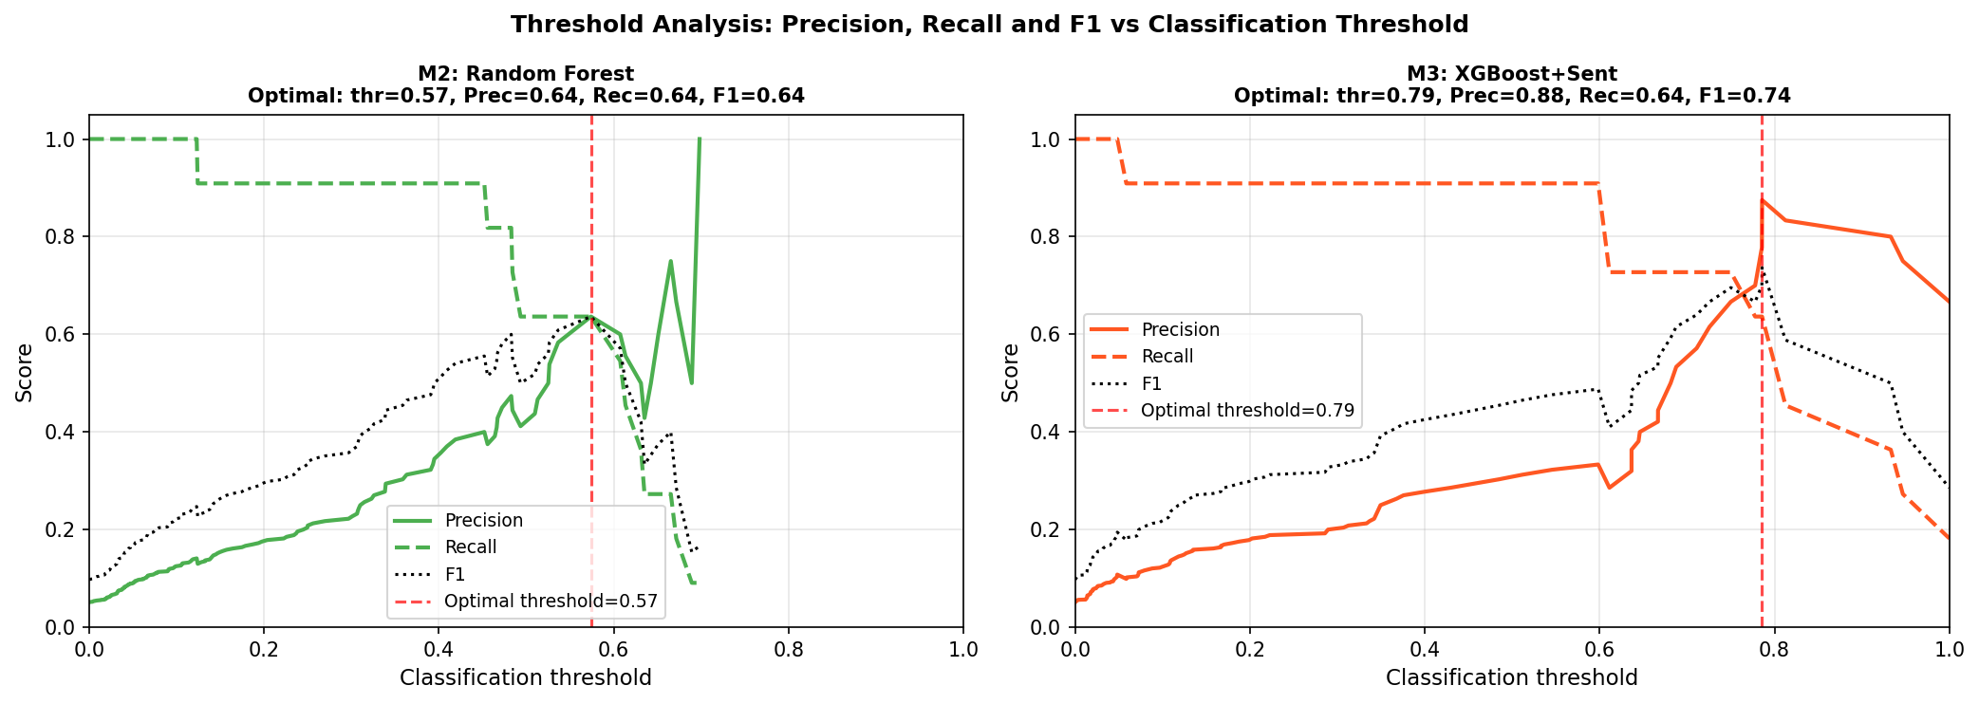
Figure A.30. Threshold analysis: Precision, Recall, and F1 vs classification threshold for M2 RF (left, optimal thr = 0.57, F1 = 0.64) and M3 XGBoost+Sentiment (right, optimal thr = 0.79, F1 = 0.74). M3 achieves a higher optimal F1 at a substantially higher threshold, indicating superior probability separation between crisis and non-crisis observations.

A.8 Multi-Horizon Performance (sentiment_improved)
Figures A.30–A.31 summarise multi-horizon results under the sentiment_improved specification. These horizons were excluded from the primary analysis due to event sparsity in the 2016–2020 test window.
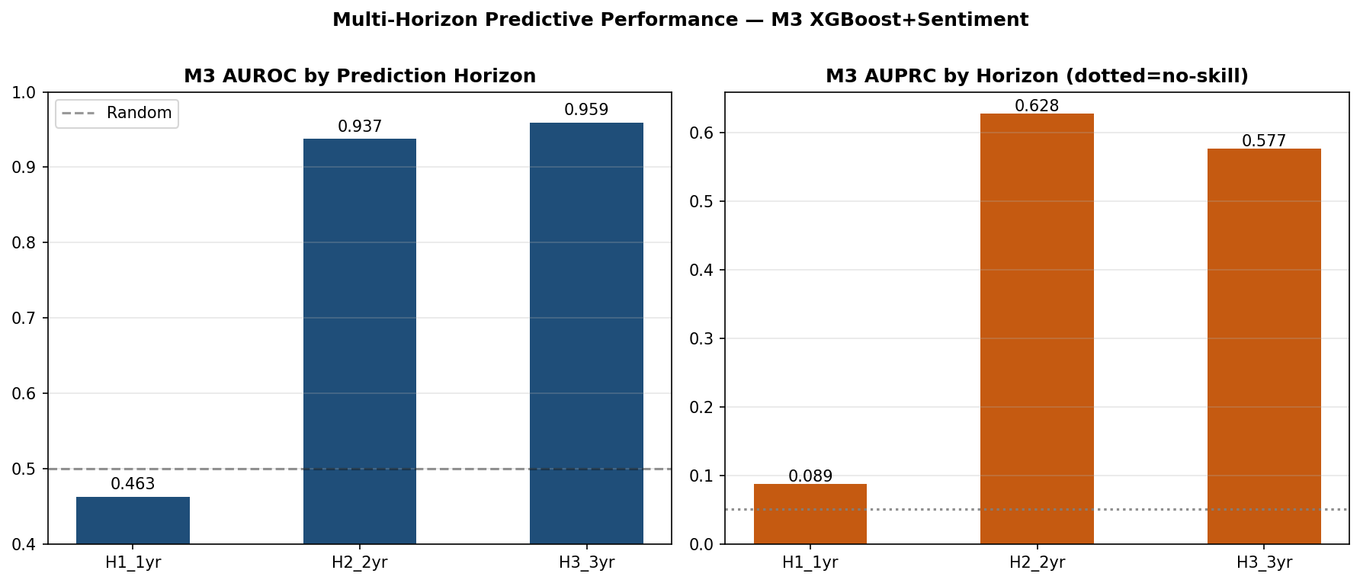
Figure A.31. M3 XGBoost+Sentiment performance by prediction horizon — sentiment_improved specification. AUROC (left) and AUPRC (right) at H1 (1-year, AUROC = 0.463), H2 (2-year, 0.937), and H3 (3-year, 0.959). H1 falls below random, while H2 and H3 are strong but inherit the same cross-sectional concentration that inflates Stage 2 expanding-window metrics. H1 AUPRC of 0.089 is close to the no-skill baseline.

Figure A.32. Sentiment AUPRC uplift by prediction horizon (sentiment_improved). Left: M2 vs M3 AUPRC at H1/H2/H3. Right: absolute uplift M3−M2 per horizon. The monotonically increasing pattern (+0.061 at H1, +0.118 at H2, +0.246 at H3) suggests longer-horizon precautionary information in central bank speeches. Reproduced here for cross-referencing with the multi-horizon AUROC results above. (Duplicate of Figure A.15 shown for direct comparison with Figure A.30.)

A.9 Original Ensemble Extension (NB09A)
Figures A.32–A.36 present the original NB09A ensemble analysis (M4 = avg(M2-matched, M3)), which preceded the EBM-based ensemble extension reported as the primary ensemble in Section 4.10. These results are included for completeness and to document the pre-EBM ensemble development trajectory.
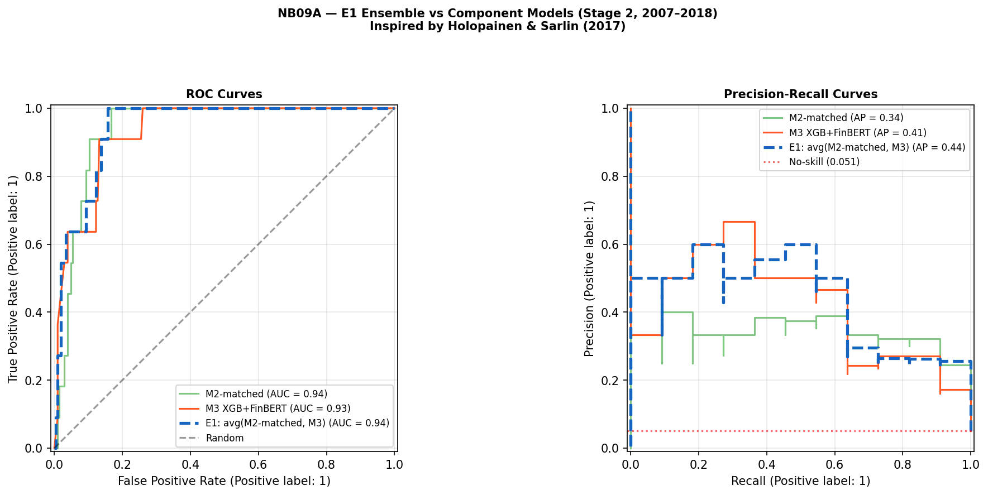
Figure A.33. NB09A E1 ensemble vs component models — ROC and PR curves, Stage 2 (2007–2018). E1 = equal-weighted average of M2-matched and M3. E1 achieves AUPRC = 0.44, a gain over both components (M2-matched 0.34, M3 0.41). Compare Figure 4.9, where the EBM-based E1-EBM ensemble achieves AUPRC = 0.43 with AUROC = 0.955.
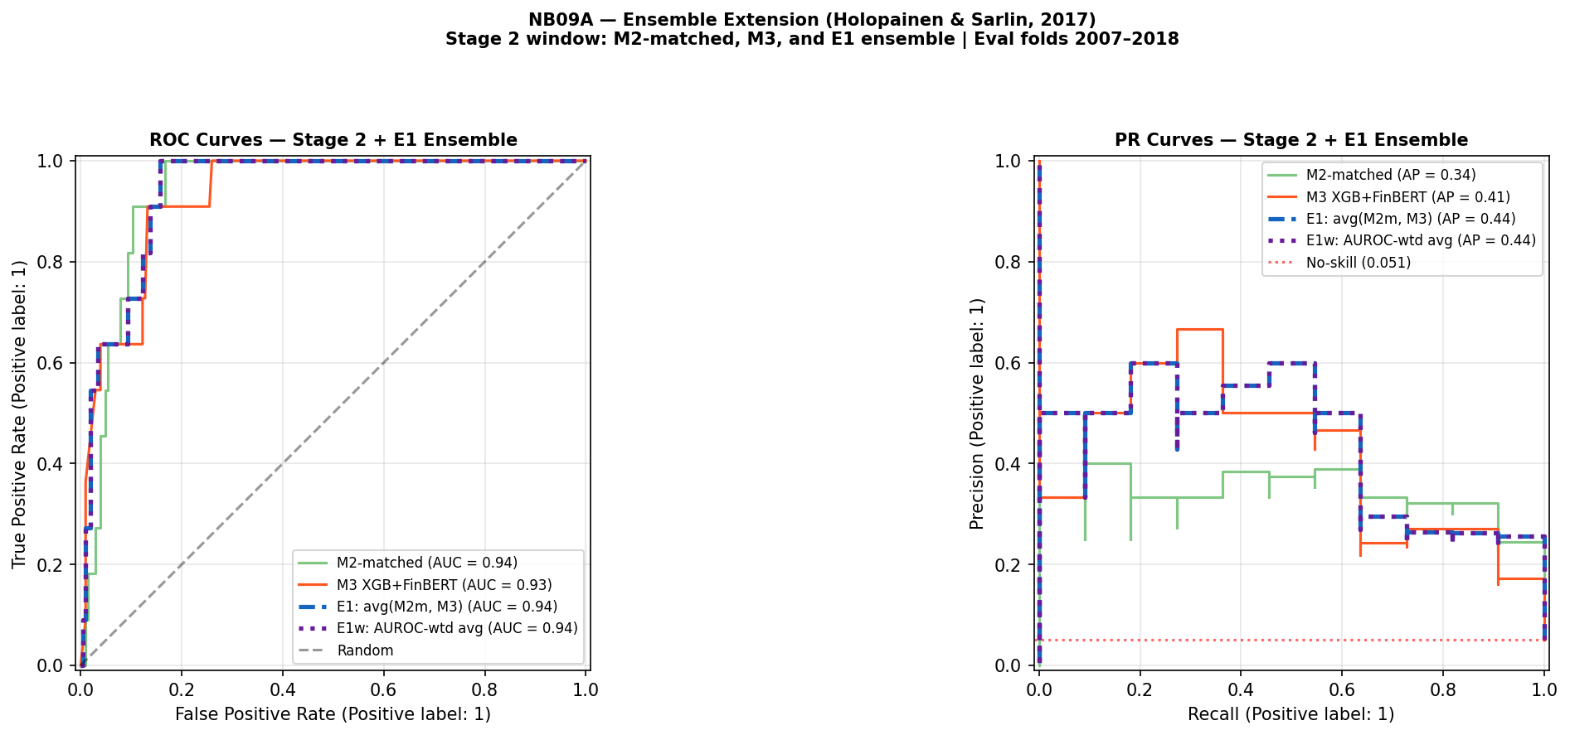
Figure A.34. NB09A ensemble variants including AUROC-weighted average (E1w) — Stage 2 ROC/PR. Both E1 and E1w achieve AUPRC = 0.44 and AUROC = 0.94, indicating that AUROC-weighting over equal weighting provides no discrimination benefit in this evaluation window. The result is consistent with the low marginal value of ensemble weighting documented for the EBM extension.
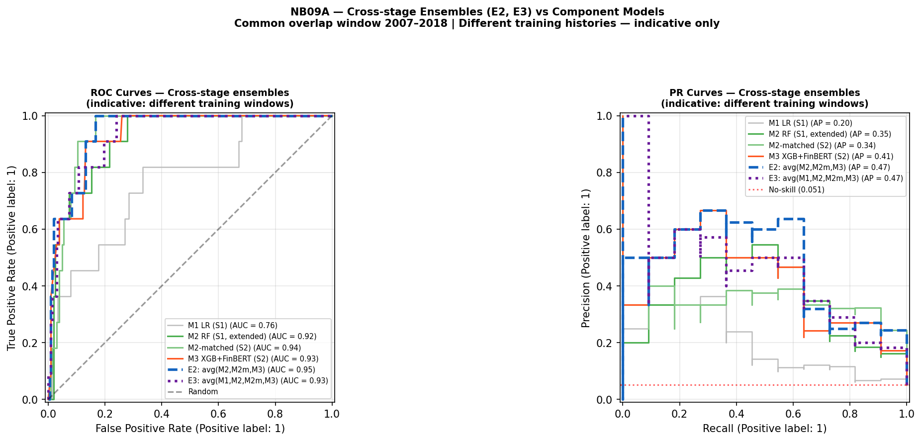
Figure A.35. NB09A cross-stage ensembles E2 (avg M2, M2m, M3) and E3 (avg M1, M2, M2m, M3) evaluated over the 2007–2018 common window. Both E2 and E3 achieve AUPRC = 0.47, marginally above E1 (0.44). Comparisons are indicative only due to different training histories across stages; cross-stage averaging cannot be treated as a fair model comparison.
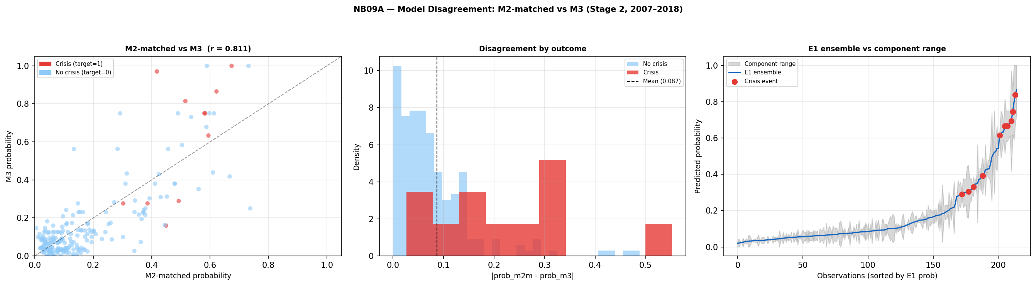
Figure A.36. NB09A model disagreement: M2-matched vs M3 (r = 0.811). Left: probability scatter coloured by crisis outcome. Centre: disagreement distribution by outcome class — crisis observations show substantially wider disagreement than non-crisis observations (mean 0.087). Right: E1 ensemble vs component range; the ensemble line remains close to the lower component bound at crisis observations. Compare Figure 4.10, which extends this analysis to include EBM M2.5 as a third component.
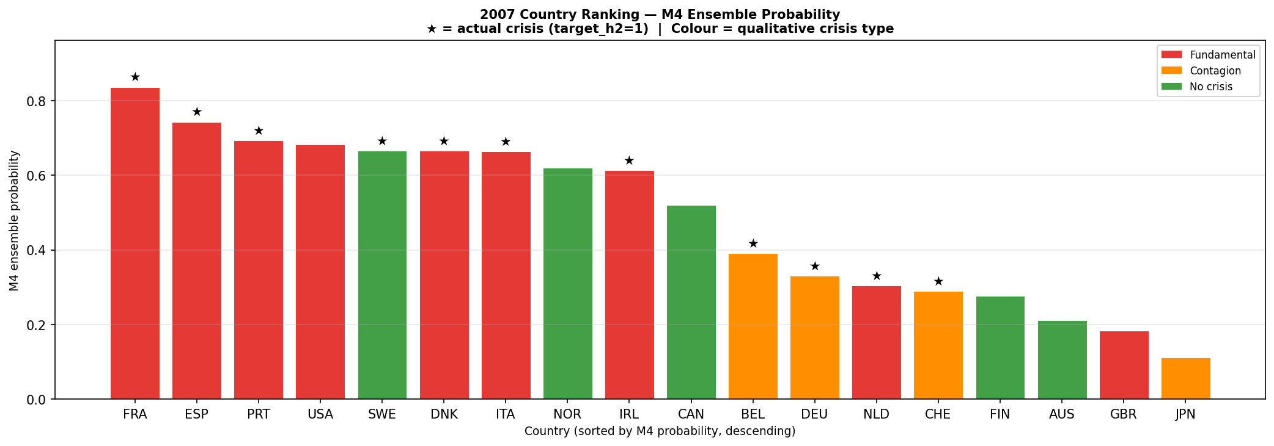
Figure A.37. 2007 country probability ranking under M4 ensemble (NB09A original specification). M4 = equal-weighted average of M2-matched and M3. France ranks first (0.84), Spain second (0.75); GBR ranks 17th (0.18) and JPN last (0.11). Compare Figure 4.11 (E1-EBM ranking), which shows a markedly different country ordering: IRL rises to rank 4, PRT falls to rank 8, and the contagion countries (SWE, DEU) are distributed differently, driven by the EBM component’s distinct feature weighting.

